**HW_LAB_1_A:**

Schematic view for simple_adder.

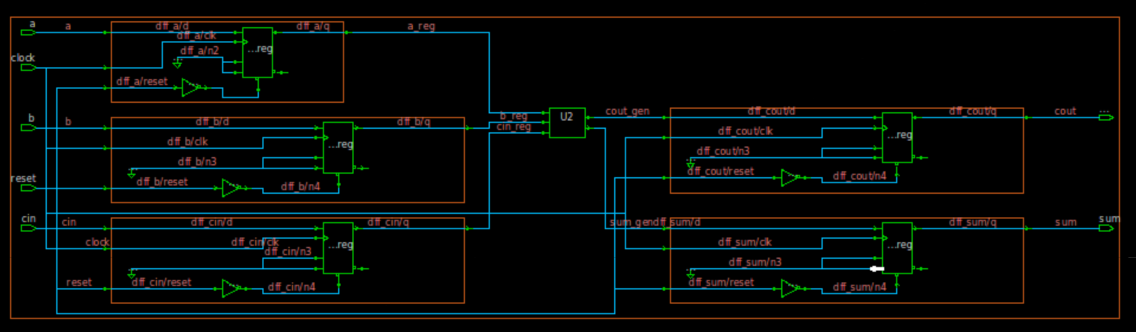

**Timing report:**

**HW_LAB_1_B:**

Schematic view

**Report timing:**

**Comparison Table**

|  |  |  |
| --- | --- | --- |
| **Constraints** | **DC** | **Genus** |
|  |  |  |
| Cell Count | 11 | 7 |
| Combinational Cell Count | 6 | 2 |
| Sequential Cell Count | 5 | 5 |
| Cell Area | 56.92826 | 41.68 |
| WNS | 0 | 0 |
| TNS | 0 | 0 |
| Violation count | 0 | 0 |

**HW_LAB_1_C:**

**FE RTL Waveform**

In detail RTL Waveform for comparison,

**BE Netlist Waveform**

In Detail Waveform for the same

**Comparison statement between FE RTL vs BE Netlist**

Waveforms are same for both Front end and Back end hence the RTL and generated netlist has same functionality.

**Questa Commands**

**vlib:** creates a design library

**vmap:** Defines the mapping between a logical library name and a directory

**vlog:** Compiles all the Verilog files

**vsim:** Starts the VHDL/Questa simulator

**HW_LAB_1_D:**

LEC equivalency.

**Commands used in LEC:**

|  |  |
| --- | --- |
| **Commands** | **Description** |
| Lec -dofile | Lec tool is invoked and commands in dofile is executed |
| Lec -tclmode | Lec tool is invoked in tclmode |

|  |  |
| --- | --- |
| **Commands** | **Description** |
| Read_design | Reads the RTL or netlist or library files required for the lec run |
| Set_system_mode | To switch system modes |
| Add_compared_points | To specify which mapped points conformal compares. |
| compare | Compare the points added in the list and tells whether he key points are equivalent or not. |

**HW_LAB_1_E:**

<https://github.com/adithyakashyap95/lab1-adit5>